COS 420

Team G

Deliverable 3

10/31

The **user** class is the public interface that accesses the rest of the domain model. The **user** has a username and password, which are used to *login*, *logout*, *create account*, and *delete account*. It does this through the **budget** class, which stores income, total expenditure, and a list of each **category**. The **user** can create a visualization of their budget or add a **category**. The **category** stores the maximum spending, amount spent, period, any alerts, and a list of each **transaction**. For a category, you can *createCategory* or *addTransactions*. Each **transaction** is a single spending instance that stores the amount spent, date, memo, and transaction ID. For a transaction, you can *createTransaction* or *editTransaction*.

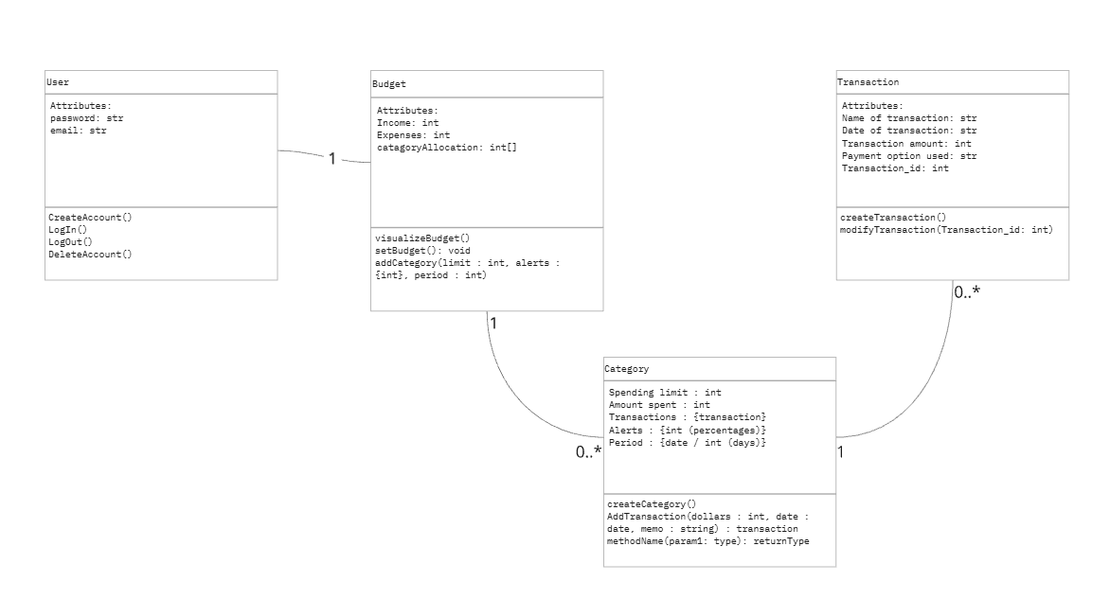

<https://miro.com/app/board/uXjVLMUAsiM=/>

**Object List**

* **User**
  + Email : string
  + Password : hash
  + Login() : Bool
  + Logout() : None
  + CreateAccount() : User
  + DeleteAccount() : None
* **Budget:**
  + Income: int
  + Expenses: int
  + categoryAllocation: int[]
* setBudget()
* visualizeBudget()
* addCategory(limit: int, alerts: [int], period: int)
* **Category**
  + Spending limit: int
  + Amount spent: int
  + Transactions : {transaction}
  + Alerts : {int (percentages)}
  + Period : {date / int (days)}
  + createCategory()
  + AddTransaction(dollars : int, date : date, memo : string) : transaction
  + methodName(param1: type): returnType
* **Transaction**
  + Name of transaction: str
  + Date of transaction: str
  + Transaction amount: int
  + Payment option used: str
  + Transaction_id: int
  + createTransaction()
  + modifyTransaction(Transaction_id: int)